Lab 04 World Editor V2

**Fufillment**

* I finished all the objectives!
* I also did extra!
  + See fractal dargons, fractal galaxies, etc.
  + See Scale/Rotate/Translate arrows
  + See Placing multiple different objects/types of objects
  + See Reading multiple transformed .world files in
  + See removing objects in the editor

**Execution**

* I do not believe there should be any unexpected requirements for running
  + Actually, if you count setting the start-up project in visual studio to world editor or game (or back and forth) that could be a requirement

**Controls**

* Pressing the X key will close the application
* Pressing W will move the camera forward
* Pressing S will move the camera backward
* Pressing A will move the camera left
* Pressing D will move the camera right
* Holding right click and moving the mouse will turn the camera
* Pressing 1 will swap to object place mode
  + The selected object to be placed (displayed in the top right as text) will be placed with its origin at the intersection point of whatever you click on, unless no objects are present then it will be placed at 0 0 0 when you click
* Pressing 2 will swap to object remove mode
  + Objects will be highlighted red when moused-over, and removed when clicked
* Pressing 3 will swap to object translate mode
  + Clicking and dragging on the arrows will move the object in the respective direction
* Pressing 4 will swap to object rotate mode
  + Clicking and dragging on the arrows will rotate the object in a semi-kinda-sorta-maybe-not-but-still-better-than-nothing-rotation-method
* Pressing 5 will swap to object scale mode
  + Clicking and dragging on the arrows will scale the object in those respective axes
    - There is sometimes a reversal with rotated objects, so if this bugs you, scale them before rotating them!
* Pressing 6 will Set the Object-To-Place to a cube
* Pressing 7 will Set the Object-To-Place to Daniel’s hideout
* Pressing 8 will Set the Object-To-Place to a small house
* Pressing 9 will save the selected object to a file, if an object is selected
* Pressing 0 will instantiate a new copy of the last saved object for the current run with the origin at 0 0 0

**Screenshots**

* + **My version control history, as of about 10:00am – as you can tell, I really did code all night – there were a few minor commits after this, but this is the bulk of the work**
  + 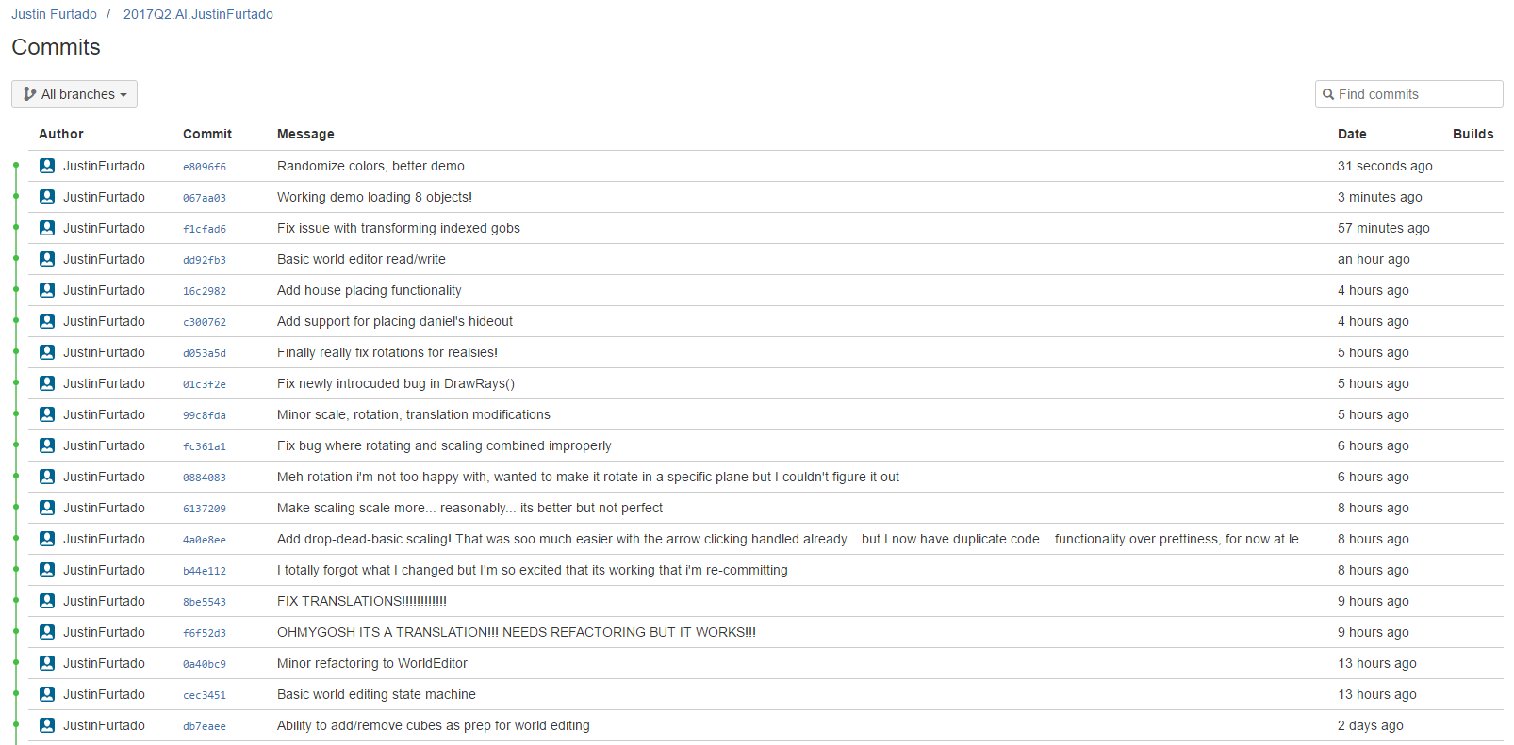
  + **My Recycle bin post-14-hour coding session**
  + 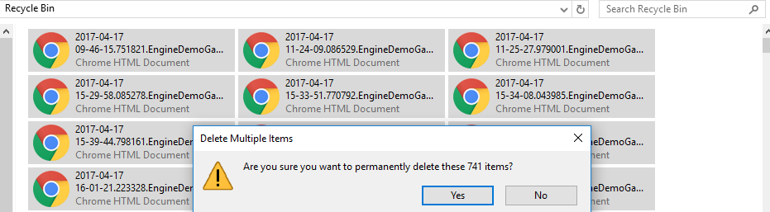
  + **An appropriate Hello, world program. Ignore the terrible writing, isn’t it cool how I made it hang off the edge like that?**
  + 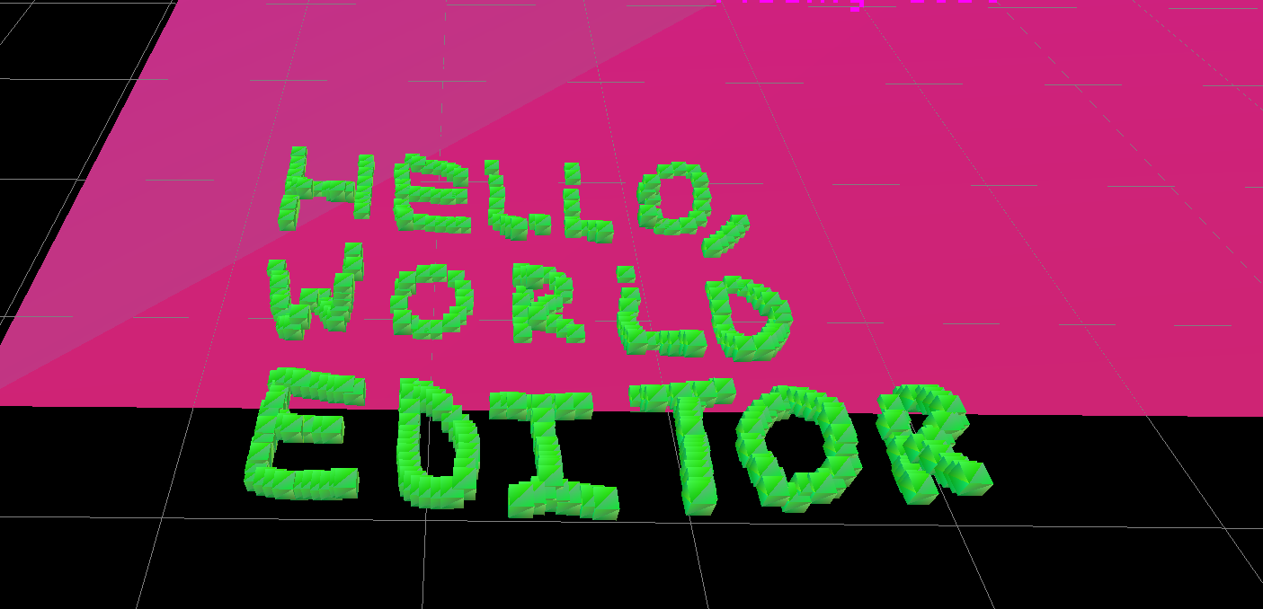
  + **Too many hideouts**
  + 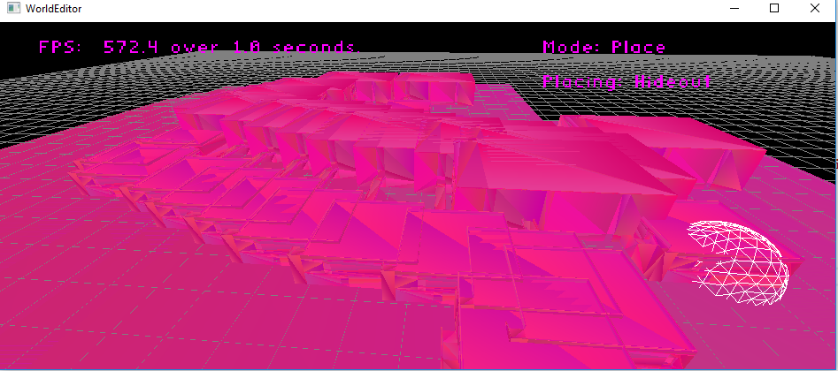
  + **Less hideouts, showing removal feature highlighting**
  + 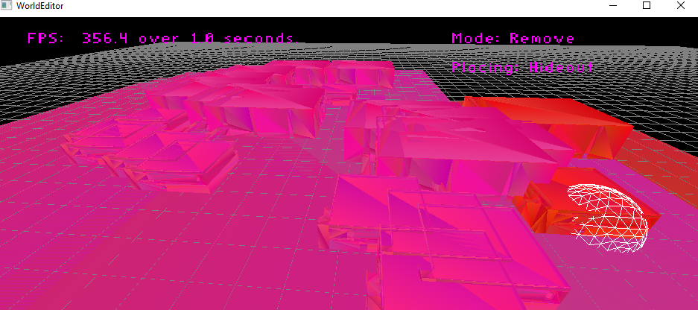
  + **My game, reading in over 60 files from my world editor**
  + 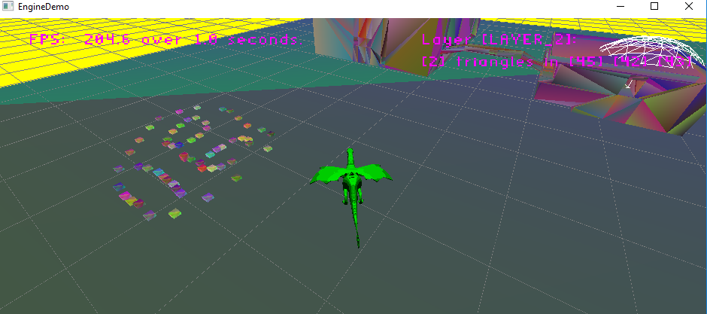
  + **Partial log info for read in**
  + 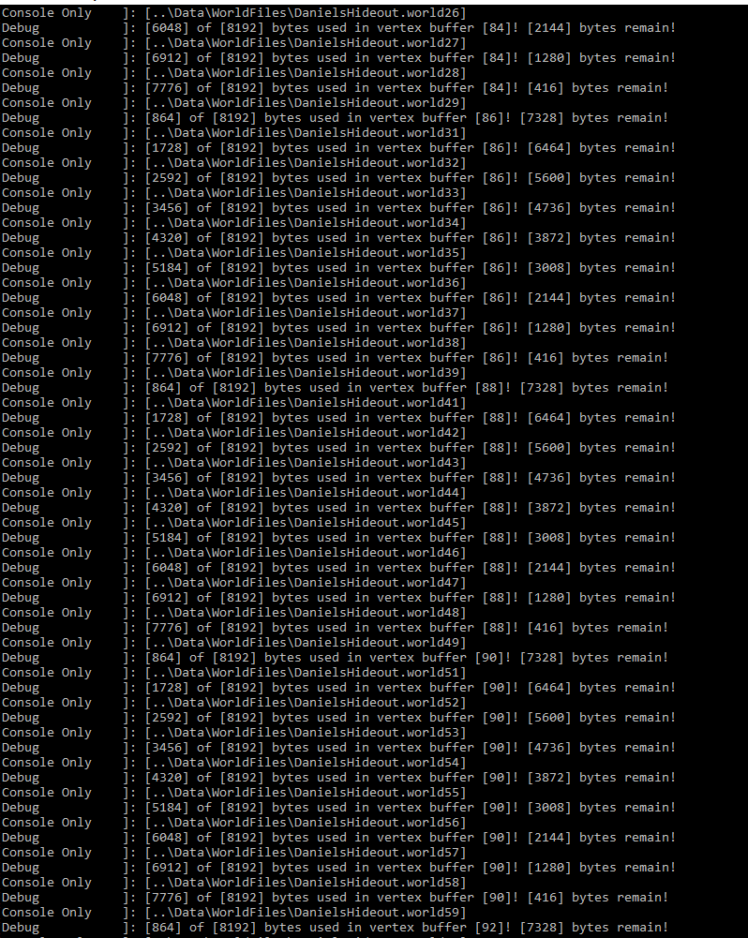
  + **A cube being translated in the world editor**
  + 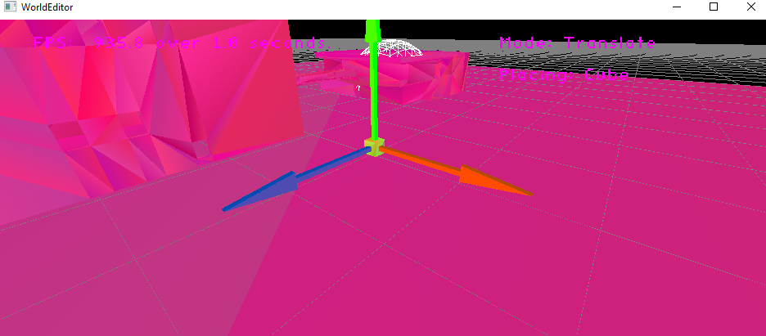
  + **The same cube, scaled in the world editor**
  + 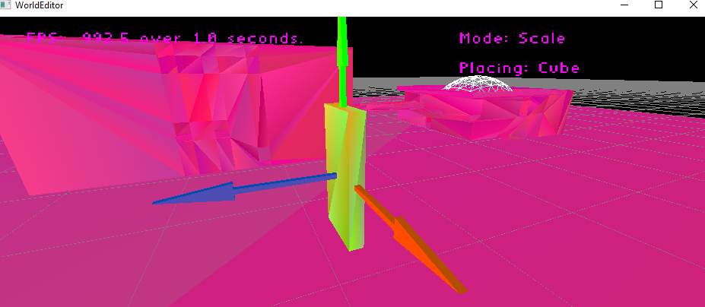
  + **The same cube, rotated in the world editor**
  + 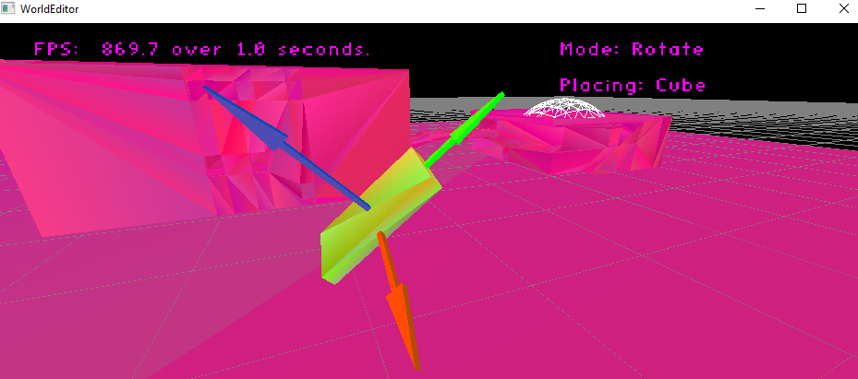
  + **More demo-ed stuff in the world editor**
  + 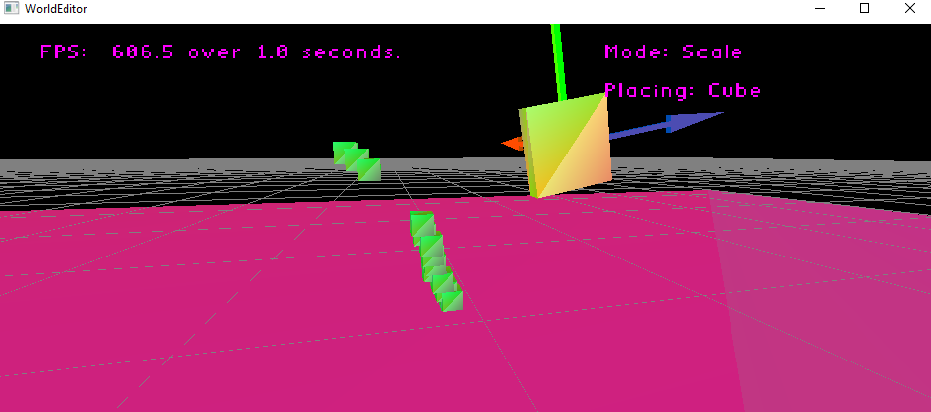
  + **Instanced rendering fractal dargon, look at that fps! Entirely made out of fractal spheres!**
  + 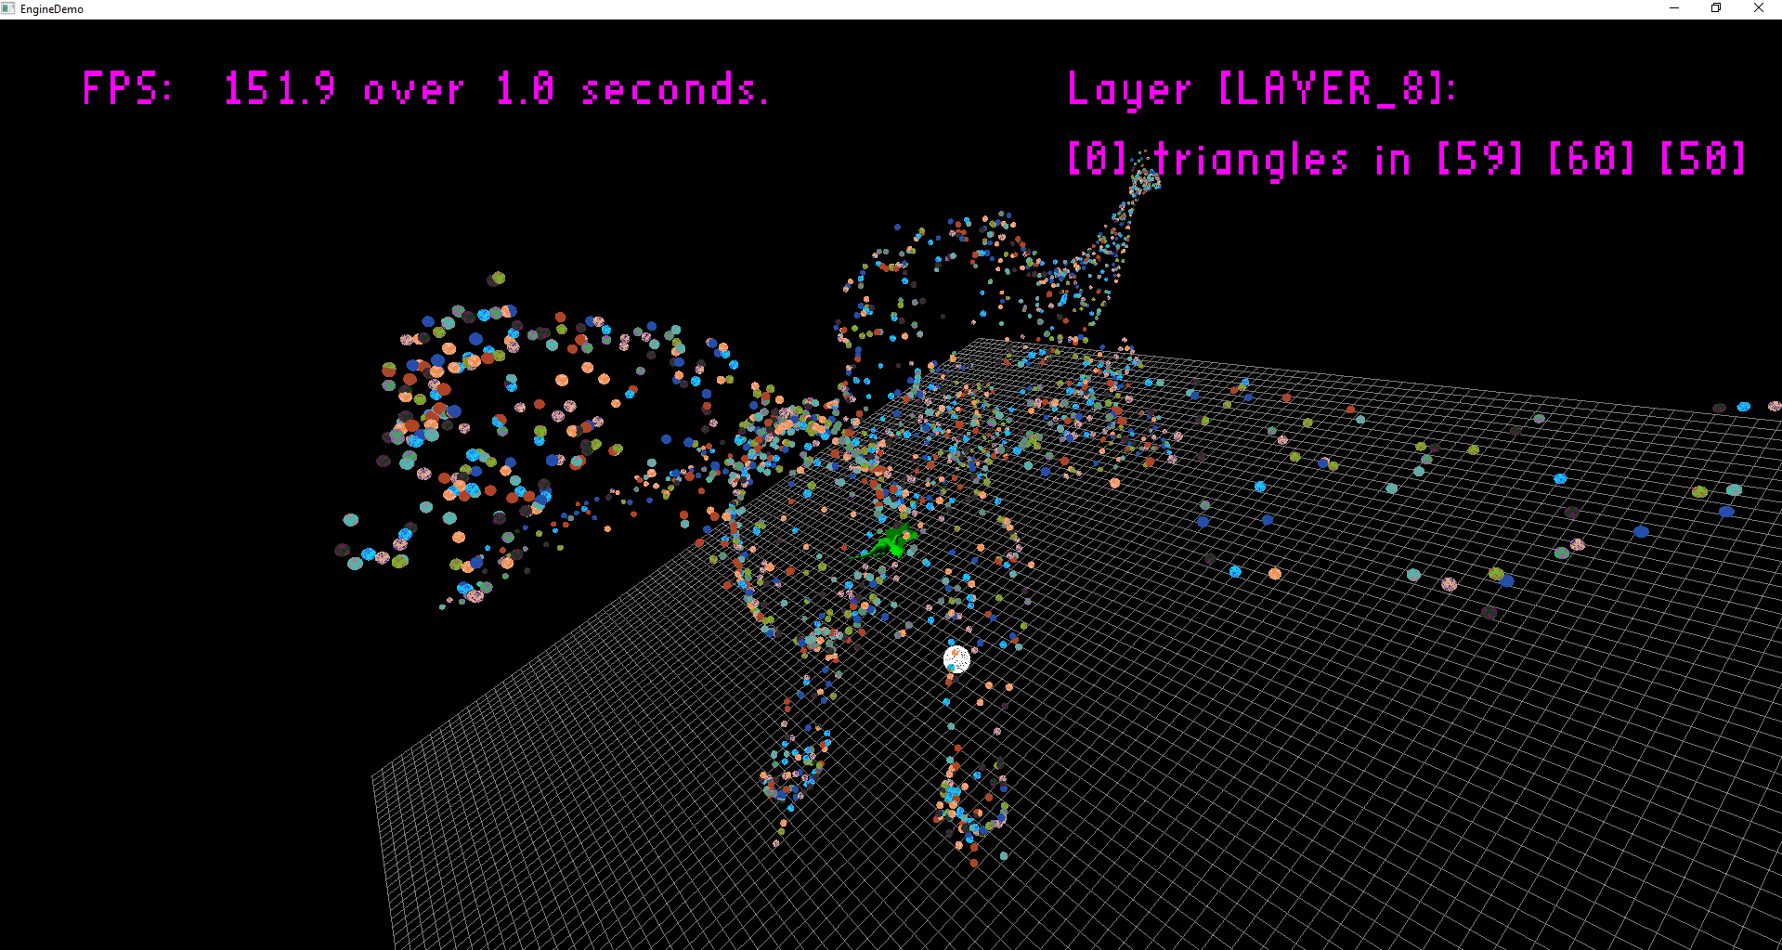
  + **Instanced fractal star**
  + 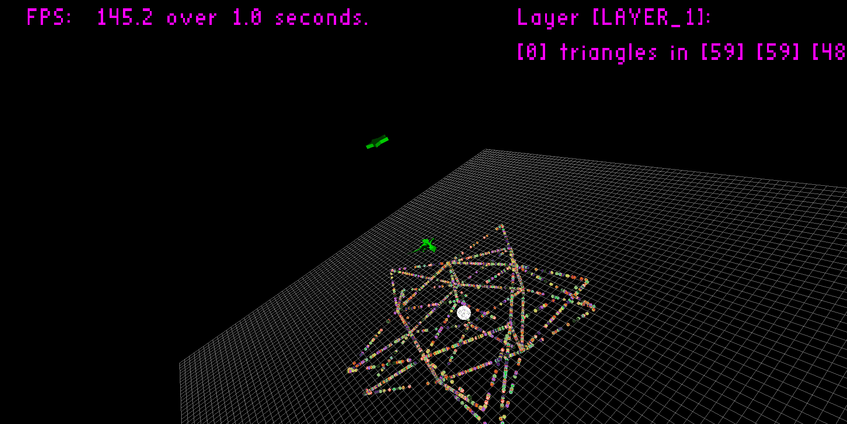
  + **Instanced fractal flag, again, all fractal spheres**
  + 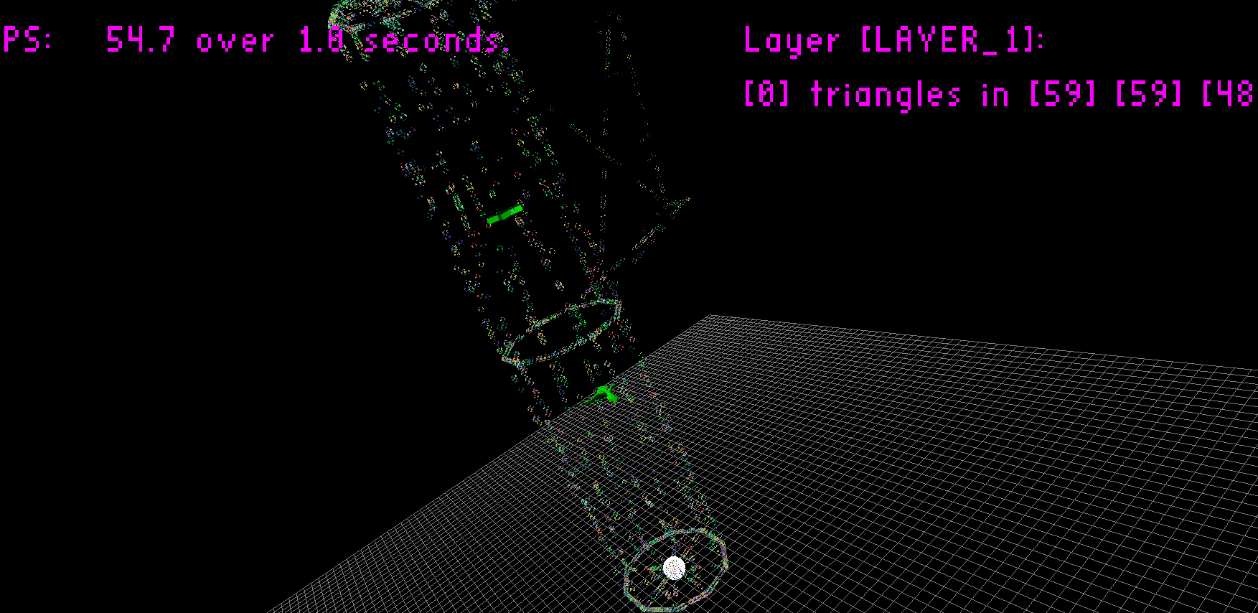
  + **Instanced fractal dargon, all fractal spheres, 10,000 of them**
  + 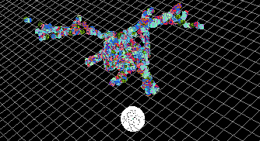
  + **Instanced fractal galaxy**
  + 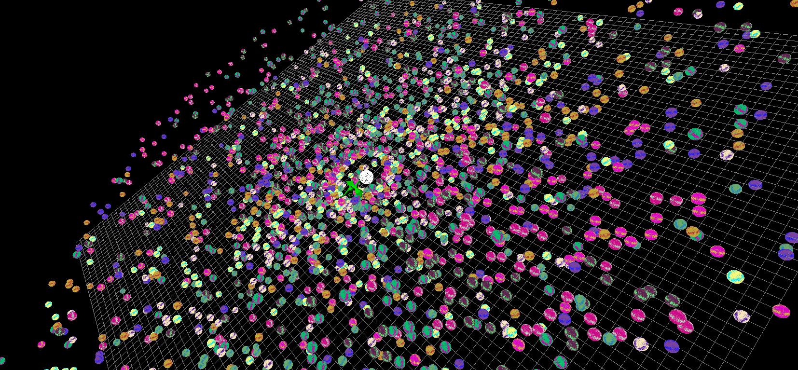
  + **Instanced fractal galaxy, at spiral time! This is one of my favorite things to watch in real time, it looks so good!**
  + 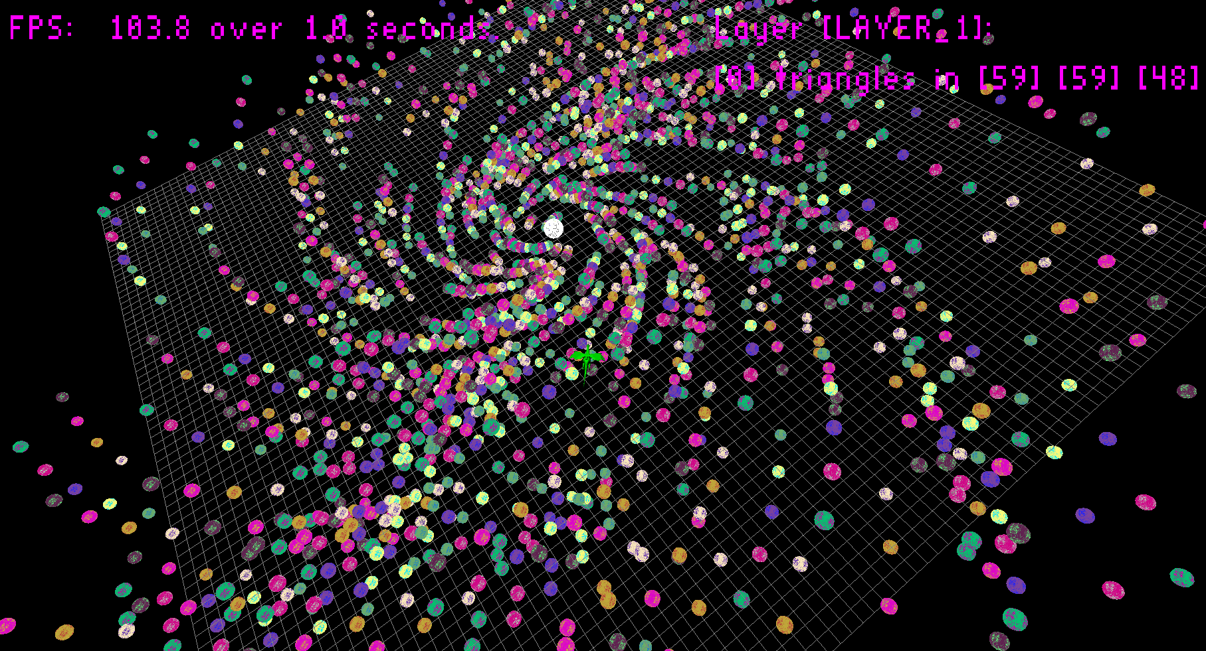
  + **Instanced fractal galaxy, alternate more helix-y edition, still awesome, though less dense**
  + 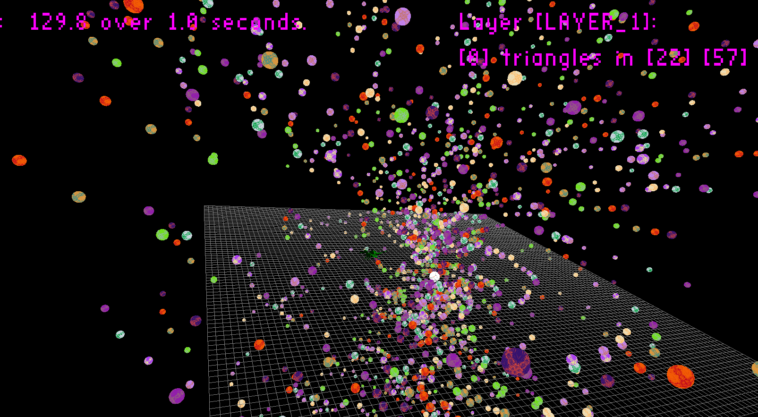
  + **Inside the instanced fractal helix galaxy at the time of a denser cluster, it is its own universe!**
  + 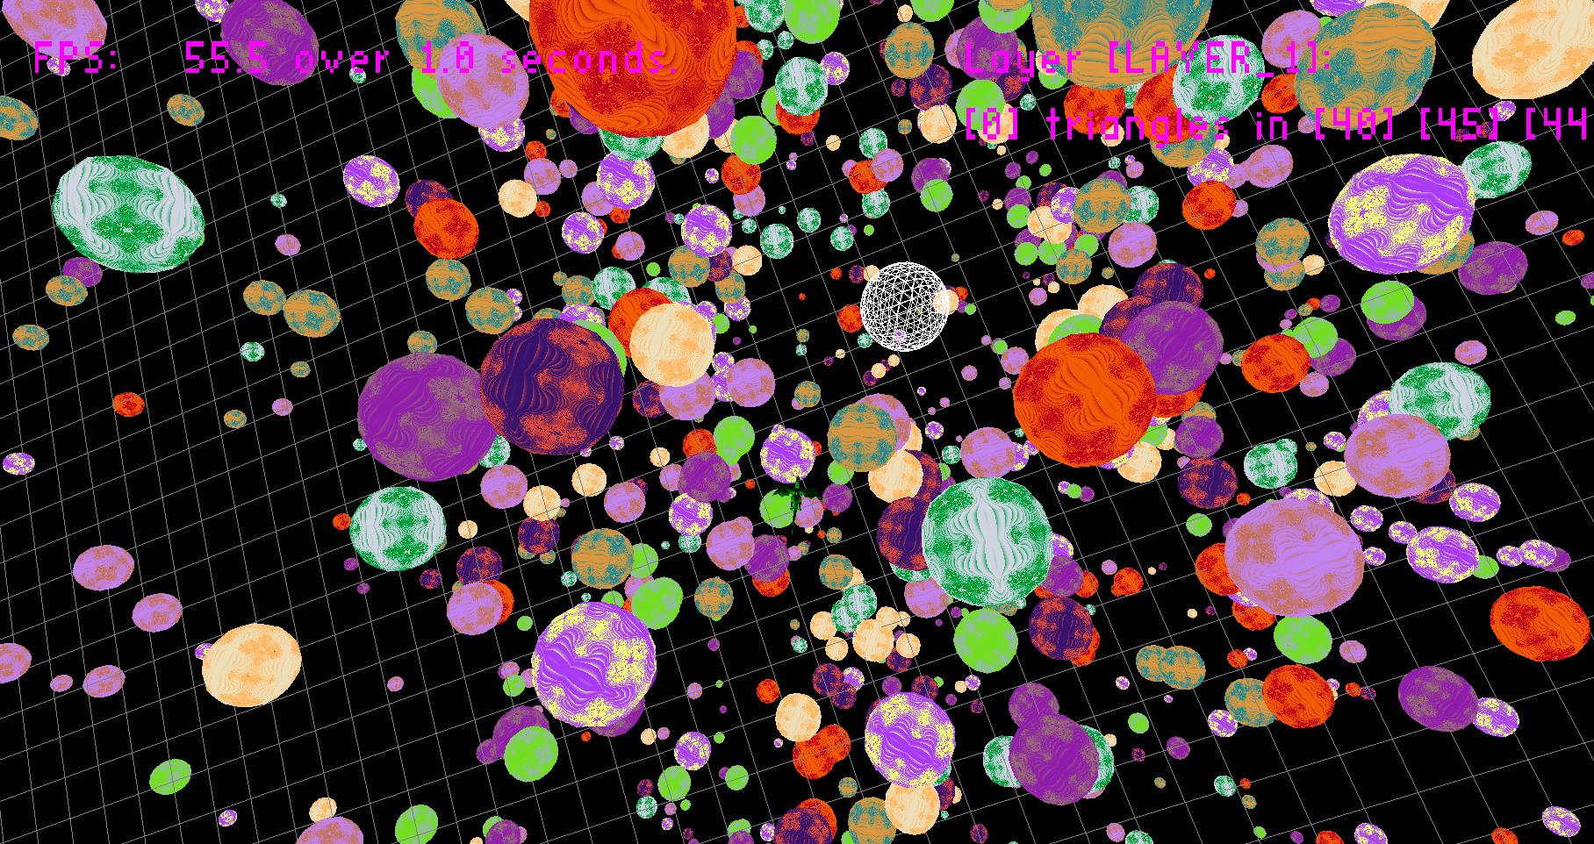

**Post-Mortem**

* I spent around 3 hours on the instanced fractal visuals, because I thought it would be fun and it wasn’t too hard when I copied some stuff over from computer graphics for instancing
  + That was really fun
* **I spent around 8 hours doing the math, writing the code, testing and fixing the scaling, rotation, translation, object placing and removing, etc. functions of the editor**
  + **This was sort-of fun but highly rewarding to accomplish**
* **I spent around 6 hours on the File IO, some general engine refactoring and tons, and tons of debugging**
  + **This was less fun, but necessary to make the other things useful and worthwhile**
* **700+ log files is a ton**
  + **So much debugging for one day (night?)!**
* **I lost sleep for this, but the feeling of accomplishment almost makes it worth it**
  + **I’d like to eventually take it further, but I’m slightly burnt out and need a few days rest first**
    - **I kind of think of it like a self-motivated game jam ☺**
      * **Speaking of which… when is the next one!?!?**
* **No errors/warnings, and even though I ran into literally dozens of bugs (half of them fixed as quickly as they were introduced and located), I did manage to fix every single bug I found – so if there are more, they are hiding!**